William Pring

6919765

Research Report #2

CNTR2115

Table of Contents

Descriptions 3

Inter- Integrated Circuit 3

One wire 3

Serial Peripheral Interface 3

Descriptions 4

PSUDO CODE: 4

FLOW CHART: 5

Information 6

Possible Sensor 6

Conclusion 6

Reflection 6

References 8

# Descriptions

## Inter- Integrated Circuit

Inter – integrated Circuit also known as I2C is a communication protocols that is synchronous. It was intended to allow multiple “slave” digital integrated circuits (“Chips”) to potentially communicate with more than one master. (SFUPTOWNMAKER, n.d.) The main intention for this protocols is for short distance communication. The physical requirements for this protocols are two wires. But, these two wires can support up to 1008 slave devices. (SFUPTOWNMAKER, n.d.) The typical speed for this communication is 100kHz or 400kHz. (SFUPTOWNMAKER, n.d.) There are also three additional modes which are Fast-modes 1MHz and high speed mode 3.4KHz. The maximum node for I2C is 1008 when it is in Fast-mode. There is some overhead that comes from using I2C and that is for every 8 bits of data being sent, one extra bit of Meta data must be sent as well. I2C is more complicated when dealing with hardware comparing to SPI. The common uses of I2C is to control LCD displays, keyboard, LED drivers, microcontrollers and RAM. (quick2wire, n.d.) These are just the few common uses that I2C can be used for. The advantages of I2C is that fact that it only requires 2 signal lines, it flexible in data transmission and that it can handle multiple master systems. (Burris, n.d.) This disadvantage of I2C is that it has a limited communication speeds that are available, many devices does not support higher speed, I2C uses more power than most serial communication busses because it uses something called “open-drain” topology and the drawback of using SPI is that is the number of pin required. (Burris, n.d.)

## One wire

One wire is a serial protocol using a single data line plus ground reference for communication. A single “master” initiates and controls a communication with one or more “slaves” over a single dateline. Note that each One Wire slave has a unique 64-bit ID which is the device address on the 1-wire bus. Eight bits of the 64 bit will be the family code which will describe the device types and functionality. The physical requirement for this protocols are 1-wire and 4.7k resistors. The bus capability is that it has 2 communication speeds which are standard mode at 16kbps and the overdrive mode at 142kbps. (Maxim, n.d.) The common uses of the One Wire are that it used in Weather Instruments. (1-Wire Price List, n.d.) Some weather instruments include testing for Humidity, temperature, wind, rain and many more weather instruments (1-Wire Price List, n.d.). It also used in computer chip called the iButton which is commonly used where information needs to travel with a person or object. (Maxim, n.d.) The advantages for One Wire is because they are very cheap and easy to uses, they are more tolerant of long wires between sensor, they provide temperatures, voltages and current reading and normally it is in devices like the iButton. The disadvantages of One Wire is that it depends a lot on precise timing (McRoberts) and Parasite Powering issue which can happening when there is the voltages drops below a critical level. (maximinte, n.d.)

## Serial Peripheral Interface

Serial Peripheral Interface also known as SPI is an interface bus that is used to send data between microcontrollers or devices. (MIKEGRUSIN, n.d.) SPI is much simpler than I2C. Only one side generate the clock which is normally the “master” and the other side is called the “Slave”. There is only one “master” but they can have many “Slaves”. In addition, there is very little overhead and data can be transmitted at high rates in both directions. Typically, there is normally three lines to transfer data between two device. Which are MISO (Master-In, Slave-Out), MOSI(Master-Out, Slave-Out), SCK(Serial Clock) and a SS to communicate with a specific slave. The physical requirements for hardware that are needed are multiple wires to communicate to different “Slaves” or you can have 1 wire communicating with multiple slave but by doing this it will lead to data overflowing. The bus capabilities speed will be 8MHz and 125kHZ. Note that SPI can operate at very high speed which can be too fast for some devices. Sometimes you will have to adjusted the speed for some devices. The most common uses of Serial Peripheral interface is Real time clocks, USB controllers, switches or serial port controller. Advantages of an SPI is that it is faster than asynchronous serial, the receive hardware can be a simple shift register, SD card, more simple, cheaper, and it supports multiple slaves. The disadvantages of SPI is that it requires more signal line, must be well define in advance, it can only work with a few feet, master has to control communications. (MIKEGRUSIN, n.d.)

# Descriptions

## PSUDO CODE:

START

Initiate Master

LOOP

IF Communicate to Sensor

Send SIGNEL to desire sensor

IF SENSOR STATUS

SEND STATUS/Information BACK TO MASTER

ENDIF

ELSE

LOG

continue

END ELSE

ENDIF

ELSE

continue

END ELSE

END LOOP

END

## FLOW CHART:

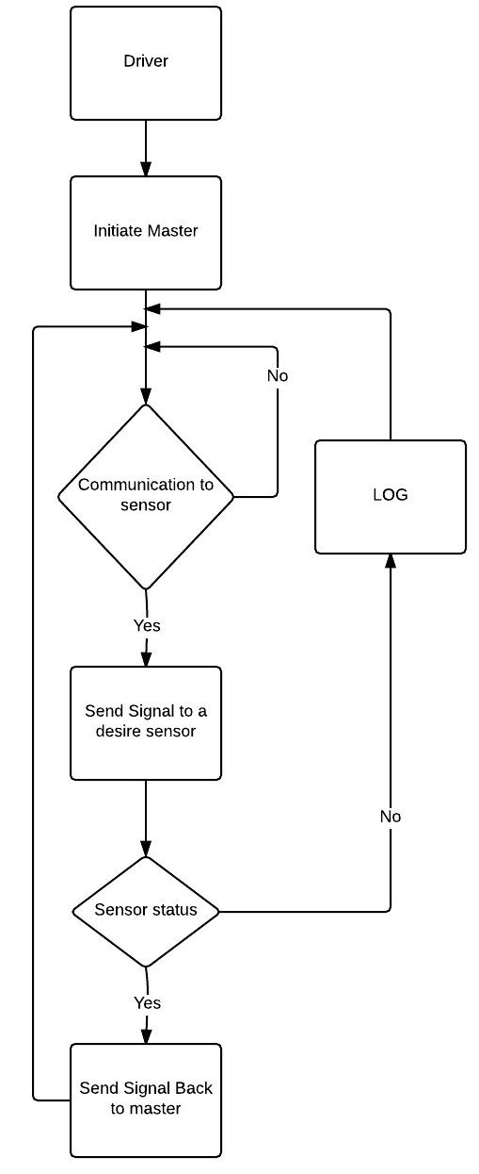

## Information

This Pseudo Code and Flow chart is first initiating the master before anything else starts. Then there is going to be a continuation loop that keeps on looping forever. Inside this loop there will be a conditional statement that will check if their master wants to communicate with the “slaves”. If the master wish to communicate with a “slave” the program will continue. If there is no communication then the program will go back to the start of the loop. Then check the sensor status to see if the sensor status is active if it is you can status or information back to master. If it is not then log the error and go to the start of the loop.

# Possible Sensor

The possible sensors that we might want to use for this projects are sensors that measure temperature and measure vibrations. For the temperature the only sensor you will need is for ambient because you will be able to get bored temperatures base on Adriano board or microprocessor you will be using. One sensor that you can use G-NICO-018 which is a temperature sensor that is compatible with SPI and I2C. The cost of one G-NIOC-018 unit is $10.34. To measure vibrations you can use Fast Vibration Sensor which cost less than a dollar. But, the Vibration Sensor does not specify the communication protocol. You can also measure vibration using ADXL345BCCZ-RL7 that is compatible with SPI and I2C. The cost of one ADXL345BCCZ-RL7 is $10.90.

# Conclusion

The reason why I picked SPI as my technology is because I believe that SPI is very beneficial for this situations is because it is a very cheap because it offers cheap hardware and inexpensive sensors. Also it is very fast in its speed. It also very easy to change or replace incase for a problem. Lastly it is more of the simpler technology to install.

# Reflection

|  |  |  |  |
| --- | --- | --- | --- |
| Document | | Self Evaluation | Score |
|  | Completeness | 5/ 5 | / 5 |
|  | Format | 3/ 5 | / 5 |
|  | Clarity / Writing | 4/ 5 | / 5 |
|  | References | 5/ 5 | / 5 |
| Document Total | | | / 20 |
| Content | | Self Evaluation | Score |
|  | I2C | 5/ 5 | / 5 |
|  | One Wire | 5/ 5 | / 5 |
|  | SPI | 5/ 5 | / 5 |
|  | Flow Chart / Pseudo Code | 4/ 5 | / 5 |
|  | Possible Sensors | 4/ 5 | / 5 |
|  | Conclusion | 4/ 5 | / 5 |
| Content Total | | | / 30 |
| Reflection | | Self Evaluation | Score |
|  | Self Evaluation Accuracy | 5/ 5 | / 5 |
| Report Total | | | / 55 |

# References

*1-Wire Price List*. (n.d.). Retrieved from txwx: http://txwx.com/price-list/1-wire-price-list/

Burris, M. (n.d.). *Overview of I2C*. Retrieved from about: http://components.about.com/od/Theory/a/Overview-Of-I2c.htm

*digikey*. (n.d.). Retrieved from digikey: http://www.digikey.ca/product-detail/en/ADXL345BCCZ-RL7/ADXL345BCCZ-RL7CT-ND/2038984

*digikey*. (n.d.). Retrieved from digikey: http://www.digikey.ca/product-detail/en/ADXL345BCCZ-RL7/ADXL345BCCZ-RL7CT-ND/2038984

Maxim. (n.d.). *WHAT IS AN IBUTTON DEVICE?* Retrieved from maximintegrated: https://www.maximintegrated.com/en/products/ibutton/ibuttons/index.cfm

maximinte. (n.d.). *Guidelines for Reliable Long Line 1-Wire Networks*. Retrieved from maximintegrated: https://www.maximintegrated.com/en/app-notes/index.mvp/id/148

McRoberts, M. (n.d.). *Beginning Arduino.* Technology In Action. Retrieved from https://books.google.ca/books?id=3TXyAAAAQBAJ&pg=PA277&lpg=PA277&dq=disadvantage+of+Onewire&source=bl&ots=vrG5cYmHaE&sig=wY2Qjb6KYgF_Pb42XWO574xTTsM&hl=en&sa=X&ved=0ahUKEwj86viGoenKAhXquoMKHUlmC1MQ6AEIJjAC#v=onepage&q=disadvantage%20of%20Onewire&f=false

MIKEGRUSIN. (n.d.). *Serial Peripheral Interface (SPI)*. Retrieved from sparkfun: https://learn.sparkfun.com/tutorials/serial-peripheral-interface-spi

quick2wire. (n.d.). *I2C and SPI*. Retrieved from quick2wire: http://quick2wire.com/articles/i2c-and-spi/

SFUPTOWNMAKER. (n.d.). *I2C*. Retrieved from sparkfun: https://learn.sparkfun.com/tutorials/i2c

*TE Connectivity Measurement Specialties G-NICO-018*. (n.d.). Retrieved from digikey: http://www.digikey.ca/product-detail/en/G-NICO-018/223-1134-ND/3736309